Marie Battle

CSD380

Module 10.2

July 21, 2024

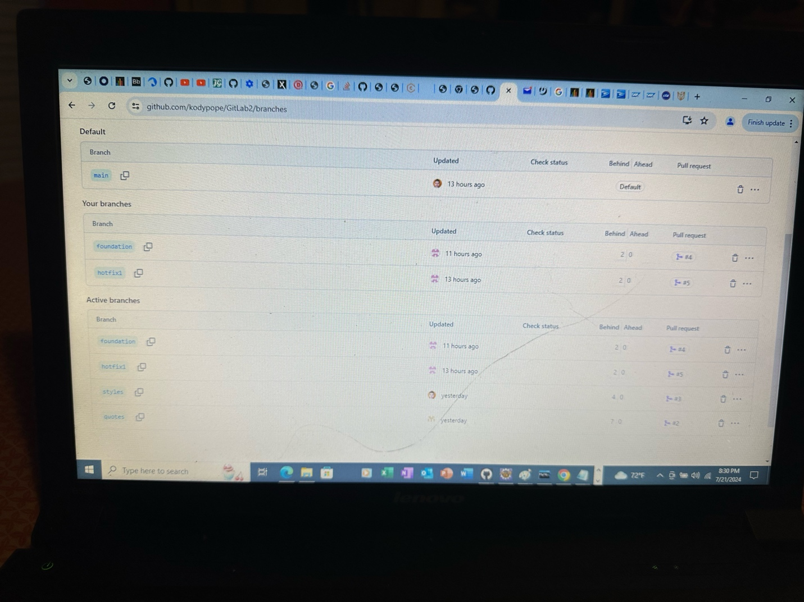July 21, 2024